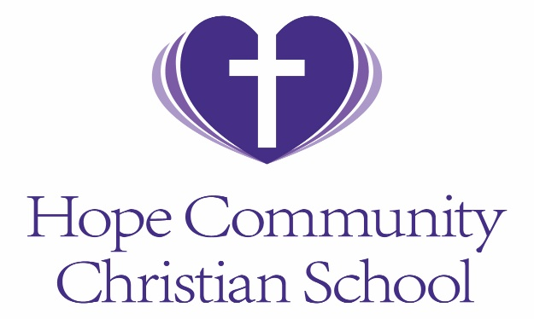
HCCS Photo Release Form
I hereby give my consent to Hope Community Christian School to photograph and publish images of me and/or my child/children on social media or publicly in the hallways of HCCS. Posted images will NOT include names.

Parent Printed Name Date

Parent Signature Date

Child’s Name Date

I do NOT want any images of my child taken while at Hope Community Chirstian School.

Parent Printed Name Date

Parent Signature Date

Child’s Name Date

